SAP FI | GUI Transaction |
GL Transaction Posting user manual

Intern
Shriganesh Marewar

Contents
GENERAL LEDGER POSTING F-01 3

SAP CONFIGURATION PATH (R):
NA

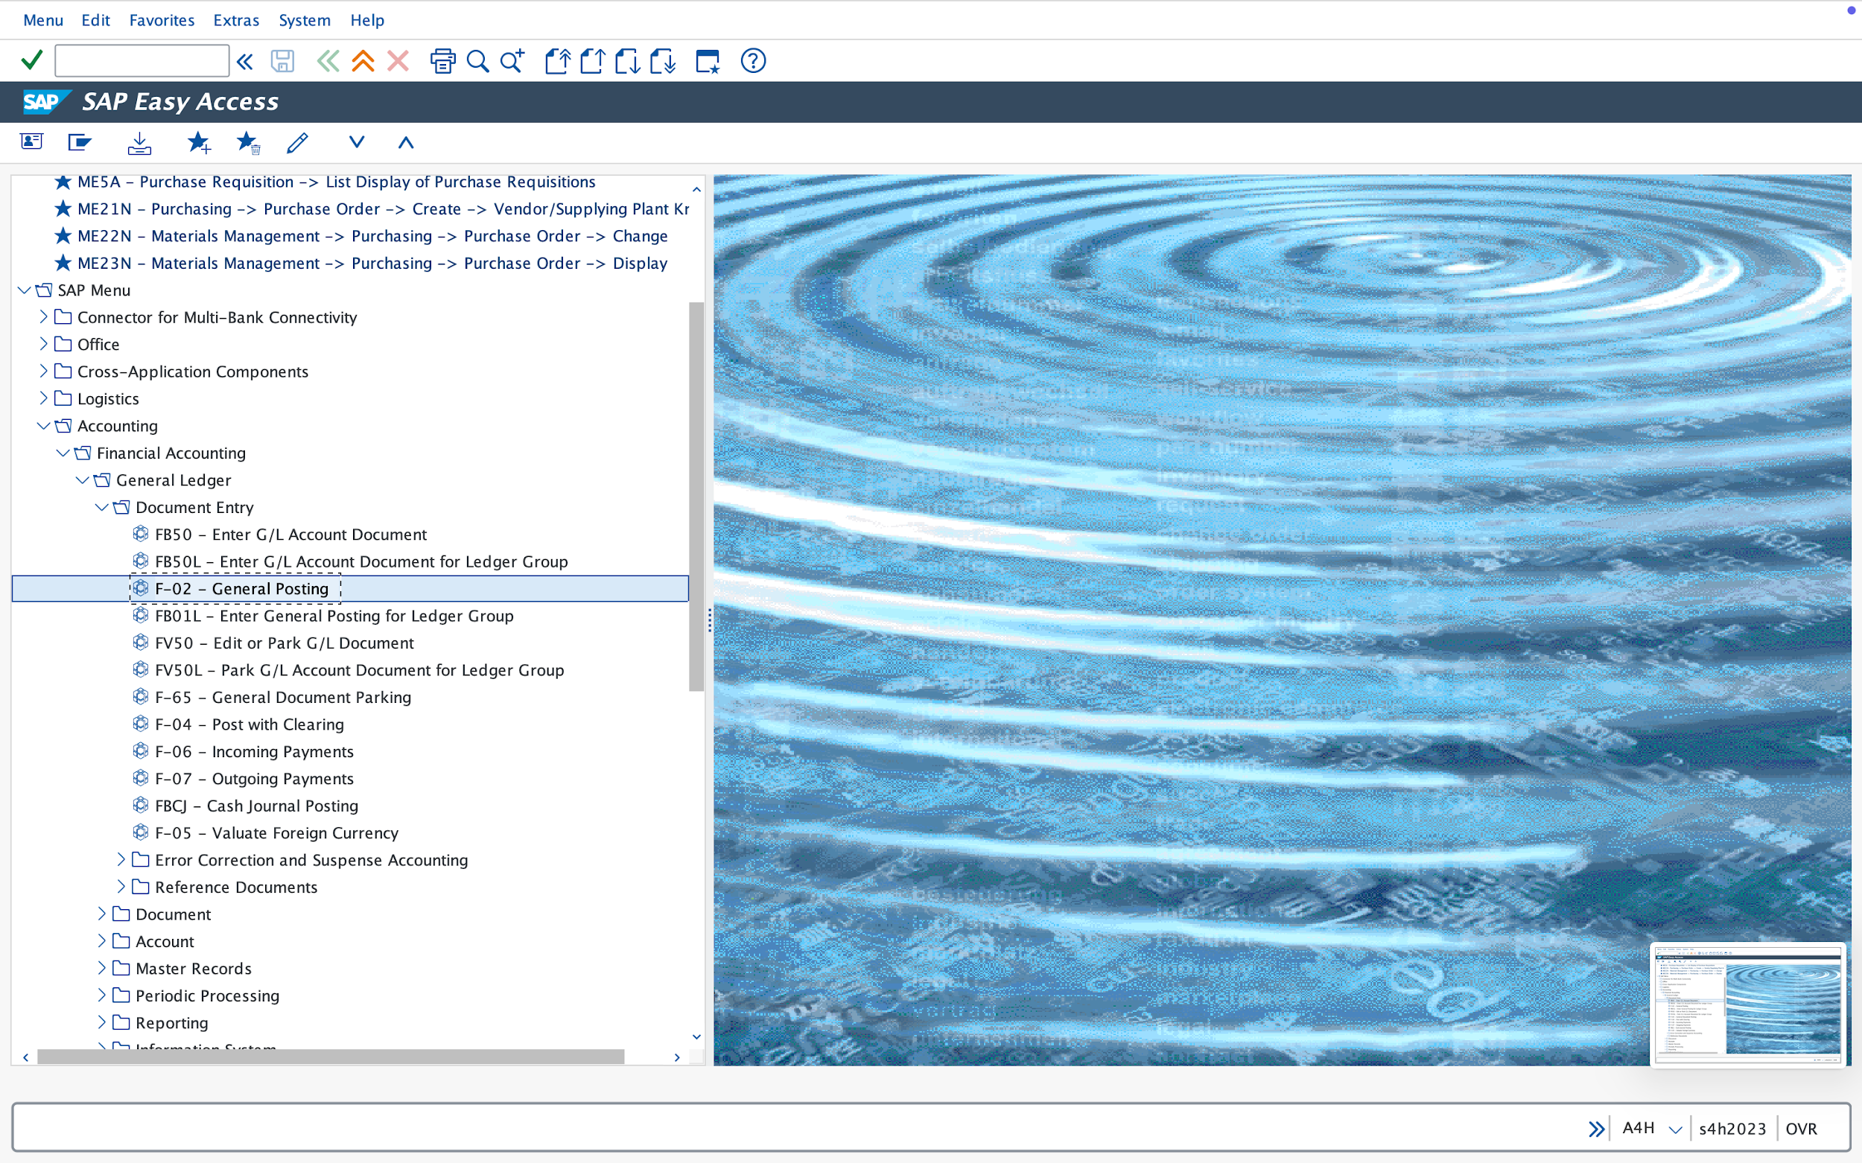

TRANSACTION CODE (R):
F-01
Please add necessary data in respective fields.
Company Code (R): Select Company Code

Document Date (R); Mention date

Posting Date (R): Mention date

Value Date (R): Mention Date.

Select G/L Account (R): Select Rent A/C or any Debiting Party

Select G/L Account (R): Select Cash A/C or any Crediting Party

Reference Number (O): it is an optional field.

Document Header Text (R): it is required as per shown in image.

Cross CC Number (O): it is an optional field.

Posting Key (R): 40(Debit) /50(credit).

Click Save - Document is Posted

Please fill up the header data

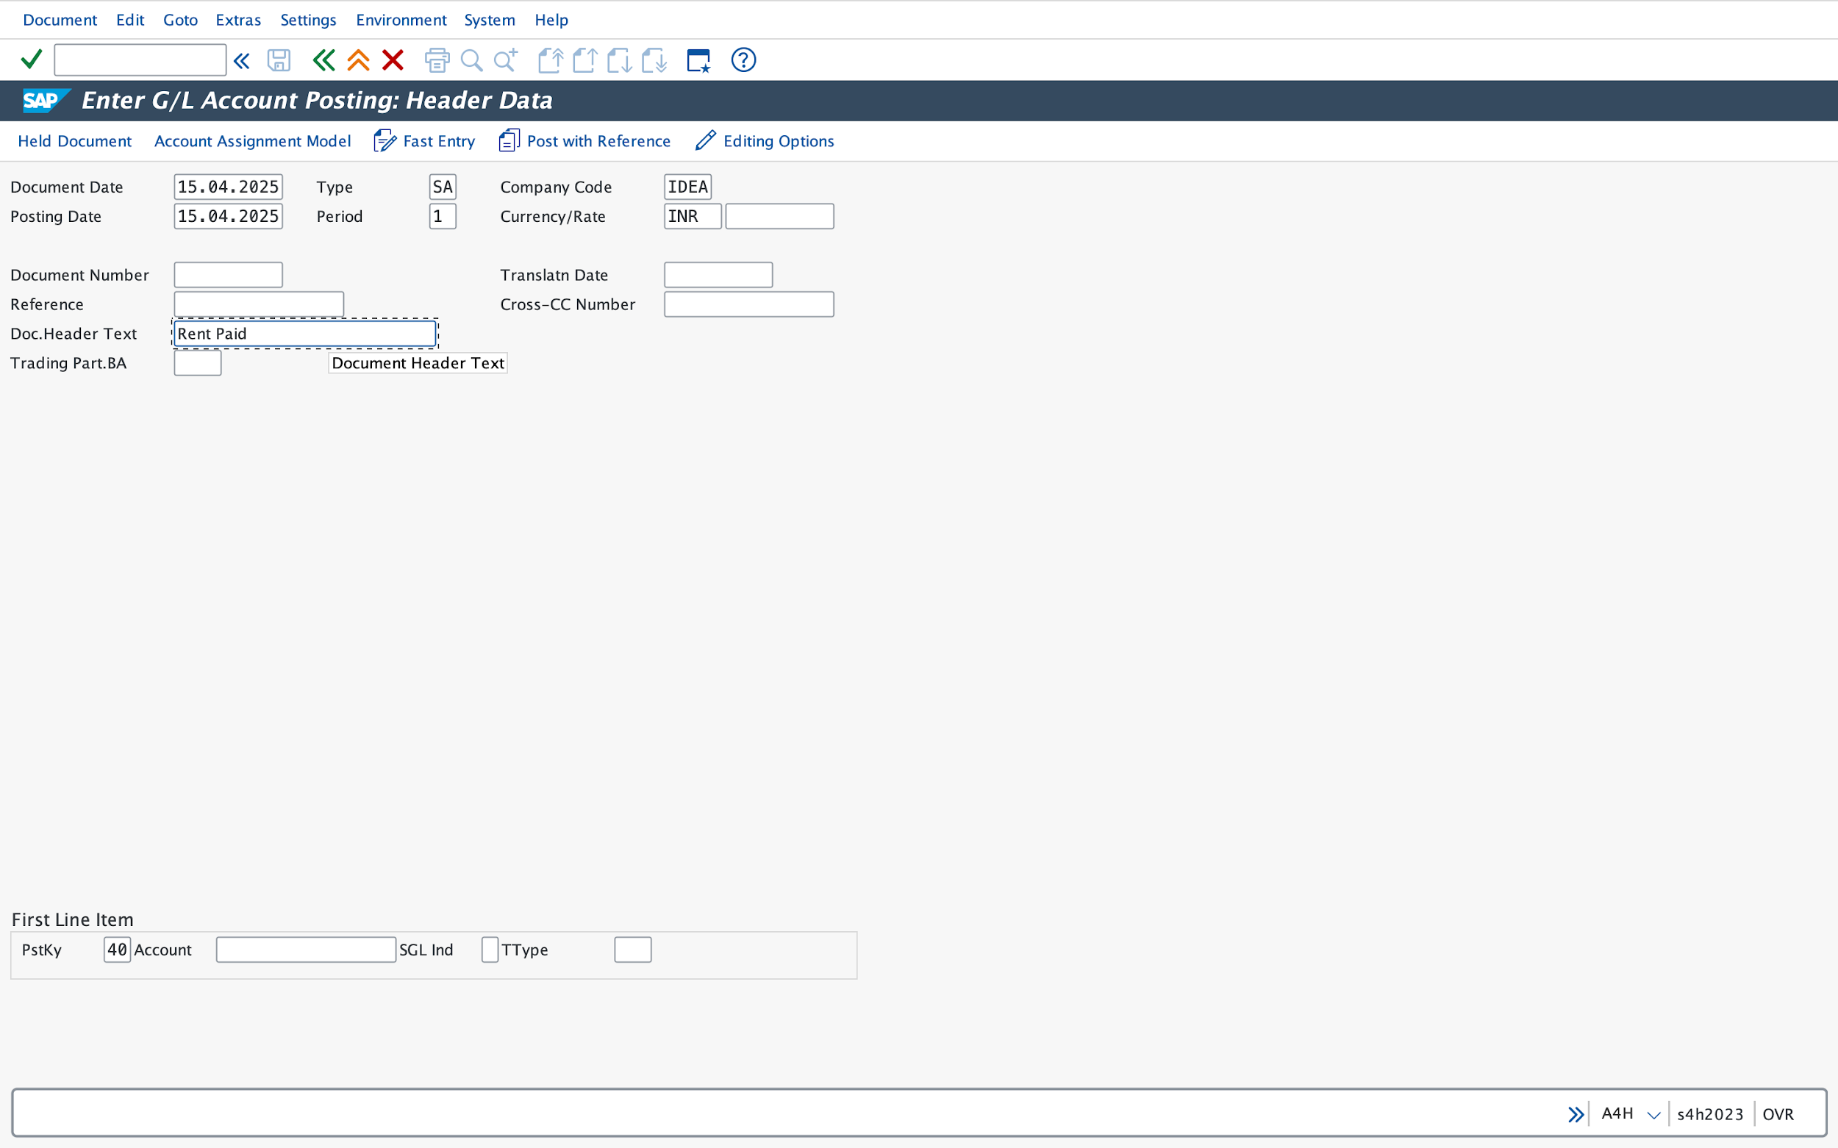

Please fill up the respective posting key, GL A/C and amount.

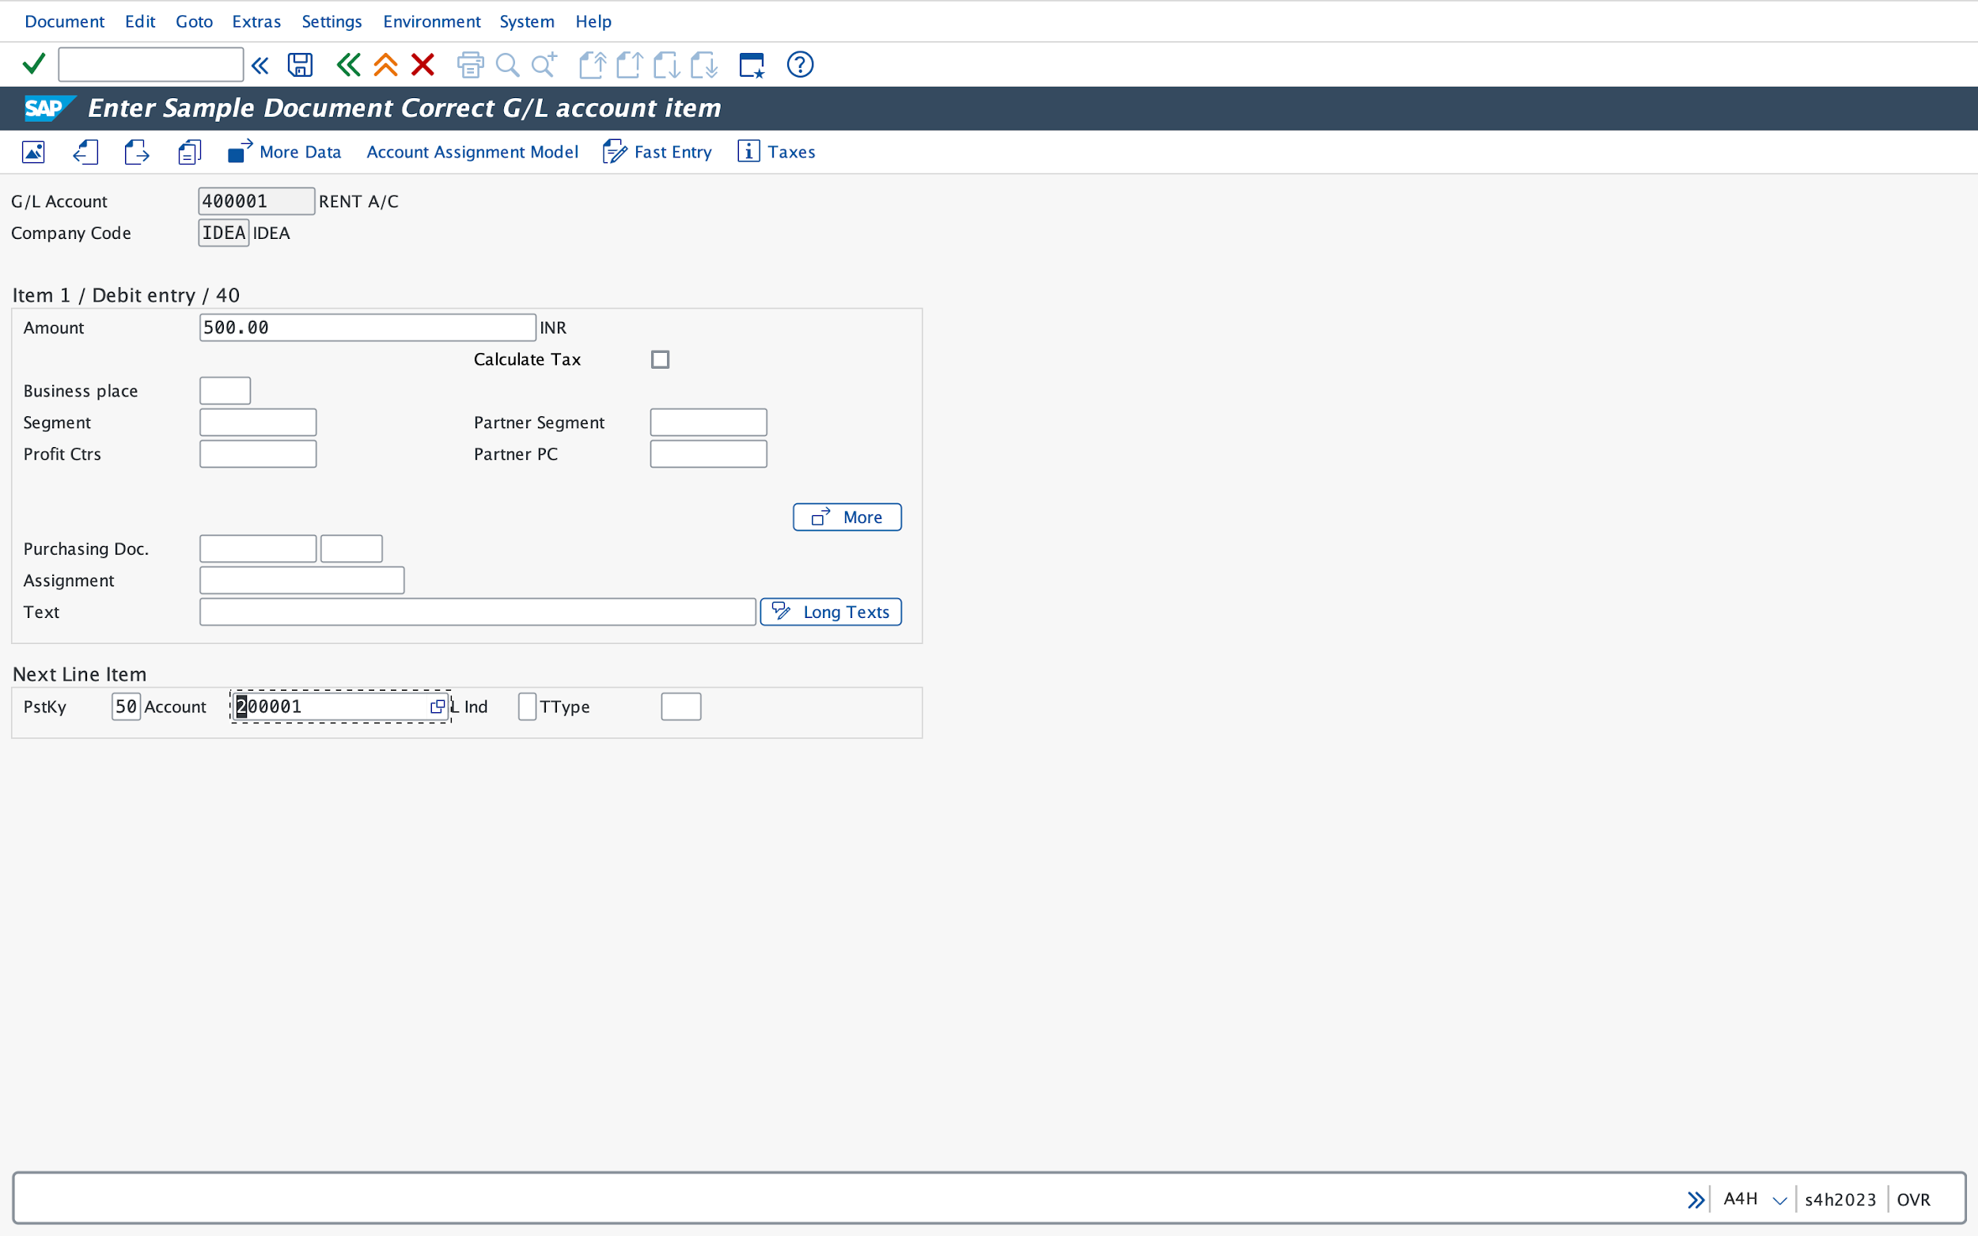

Please fill up the respective value date.

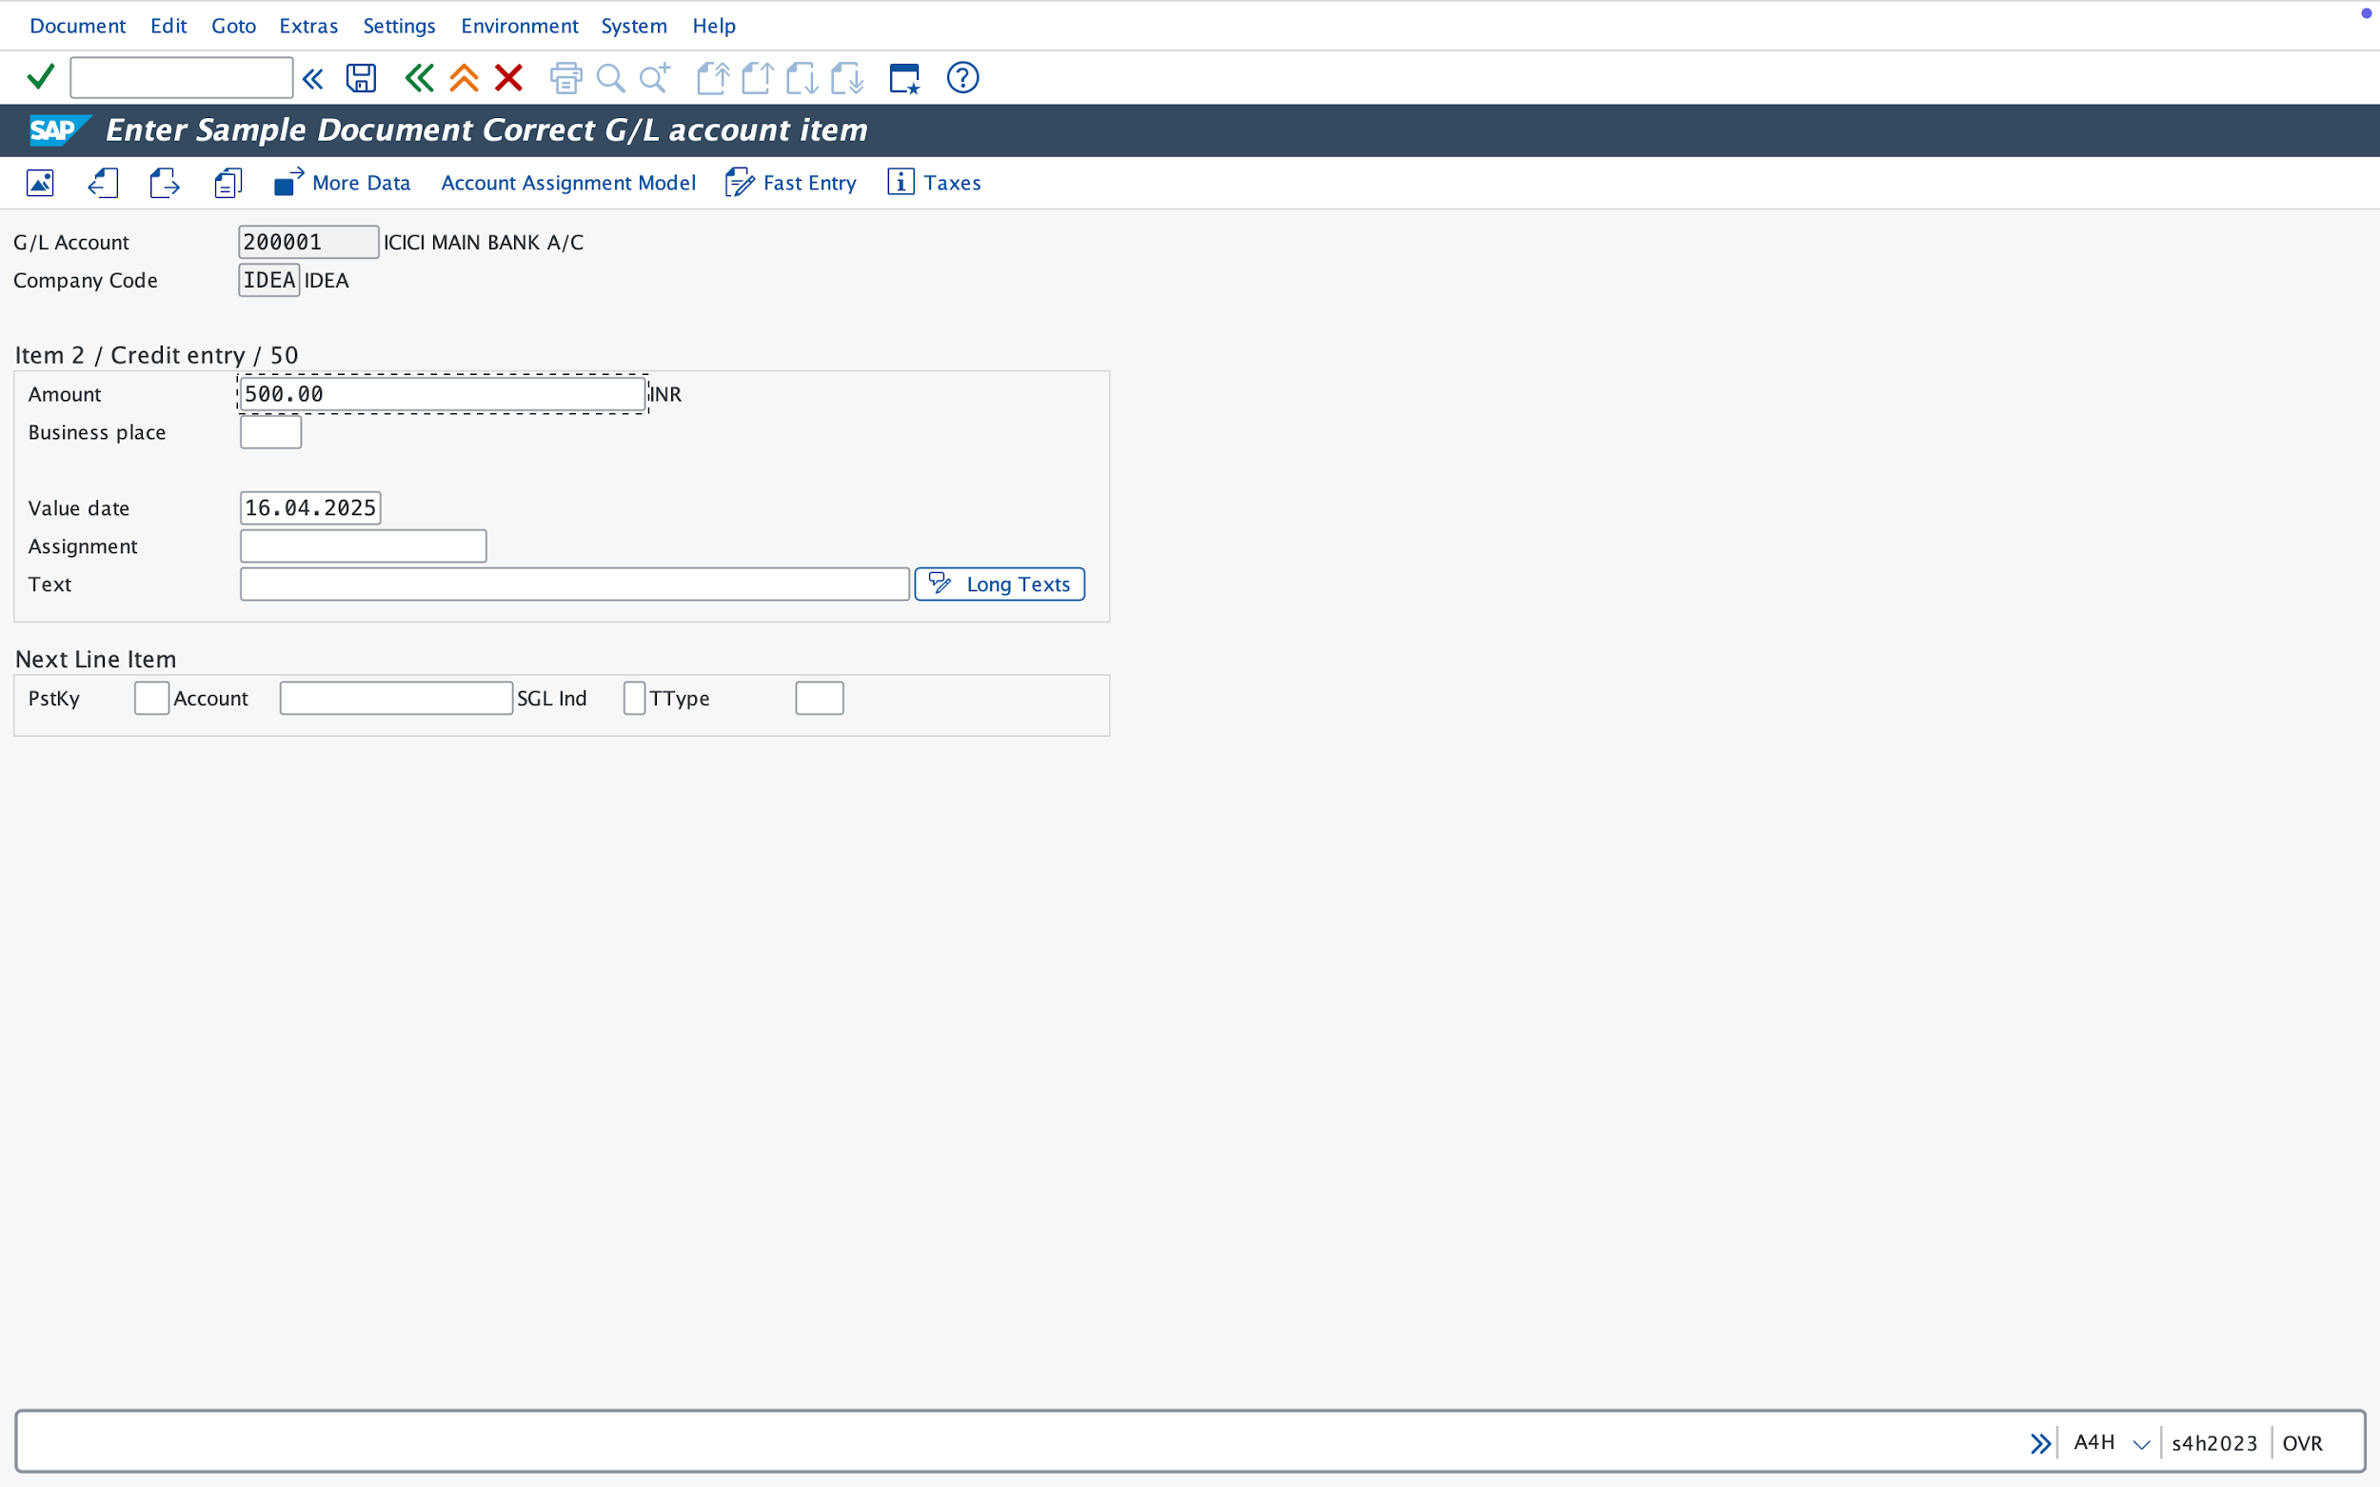

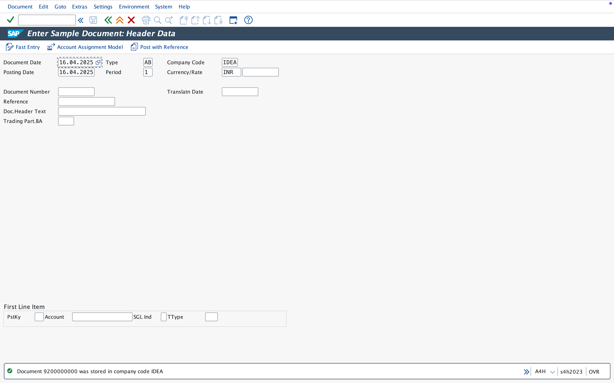

Document is saved.

SAP TABLE FOR F-01:
BKPF

